LAB REPORT: INTRODUCTION TO DEVELOPMENT TOOLS, BASICS OF C PROGRAMMING AND DEBUGGING

1. Objectives
- To learn how to set up and use an Integrated Development Environment (Code::Blocks) for C programming.
- To understand the process of compiling and executing a C program.
- To identify and fix syntax errors in a given C program.
- To utilize a debugger to find and correct logical errors in a program.
- To implement and test piecewise functions based on given specifications.
2. Software Used
- Code::Blocks IDE with MinGW C Compiler / DevC++.

Task 1: Fix Syntax Errors
Original Code (with errors):
#include <stdio.h>
#include <stdlib.h>
int main()
{ int N = 0;
printf("Enter a number for which you want to find the factorial: \n");
Scanf("%d", &N);
printf("\nYou entered: %d\n\n", n); int R = 0; int x = 0; x = N-1; R = N
do { R = R * x;
X = X-1;
}while(x>=1); // repeat above steps from multiplication till x is greater than or equal to 1
Printf(‘The factorial of %d is %d\n\n’ N, R); return 0; }
Error | Correction
Scanf (capital S) | scanf
n (undefined variable) | N
Missing semicolon after R = N | R = N;
X = X-1 (capital X) | x = x - 1;
Printf (capital P) | printf
Curly quotes ‘ ’ | Curly quotes ‘ ’
Missing comma in printf | printf("...", N, R);

Corrected Code:
#include <stdio.h>
#include <stdlib.h>
int main()
{
int N = 0;
printf("Enter a number for which you want to find the factorial: \n");
scanf("%d", &N);
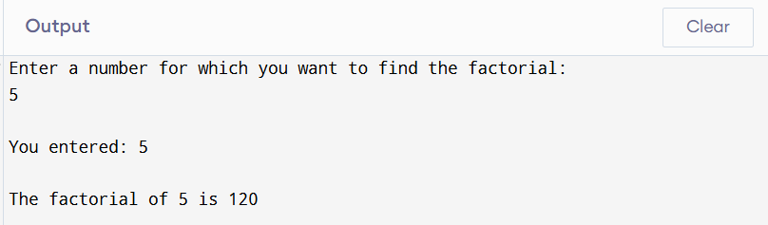
printf("\nYou entered: %d\n\n", N);
int R = 0; int x = 0; x = N-1; R = N;
do {
R = R * x;
x = x - 1;
}while(x>=1);
printf("The factorial of %d is %d\n\n", N, R);
return 0;
}
Conclusion
This task demonstrated numerous common syntax errors in C programming: case sensitivity (Scanf vs scanf, X vs x), missing semicolons, undeclared variables (n vs N), incorrect quotation marks, and missing commas in printf statements. After identifying and correcting all seven syntax errors, the program successfully compiled and correctly calculated the factorial of 5 as 120. This highlights the importance of careful attention to C language syntax rules.
Task 2: Manual Calculation of Piecewise Function
Equation:
$$f[n]=\left\{\begin{matrix}n^{2}-5n, & n≤-10 \\ n+19, & -10<n<-2 \\ n^{3}-50n, & n≥-2\end{matrix}\right.$$
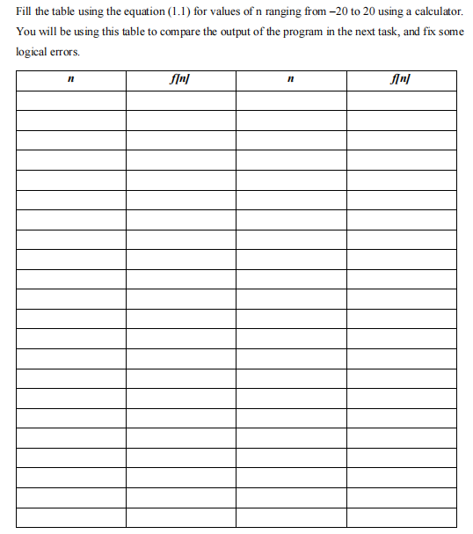
Conclusion
Manual calculation of the piecewise function provides a reference table for verifying program output. The function behaves differently across three distinct ranges: quadratic for n ≤ -10, linear for -10 < n < -2, and cubic for n ≥ -2. Notice the discontinuity at n = -2 where the function jumps from 16 (at n = -3) to 92 (at n = -2). This reference table is essential for identifying logical errors in the Task 3 program.
Task 3: Finding Logical Errors in Code using Debugger
#include <stdio.h>
#include <math.h>
int main()
{
int n, f;
for (n = -20; n <= 20; n++)
{
if (n <= -10)
f = pow(n, 2) - 5 * n;
else if (-10 < n < -2) // LOGICAL ERROR
f = n + 19;
else if (n >= -2)
f = pow(n, 3) - 50 * n;
printf("For n = %d, f = %d\n", n, f);
}
return 0;
Identifying logical errors
ERROR | IMPACT | CORRECTION
-10 < n < -2 | Condition always false; middle case never executes | (n > -10 && n < -2)
Using pow() for integers | Inefficient, possible precision issues | Use n*n and n*n*n

Comparison (n = -9 to -3):
n | expected | Original output | Corrected output
-9 | 10 | -3699 | 10
-3 | 14 | -3875 | 14
-5 | 16 | -4023 | 16

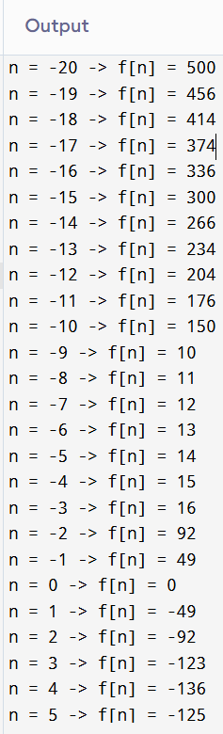
Corrected code
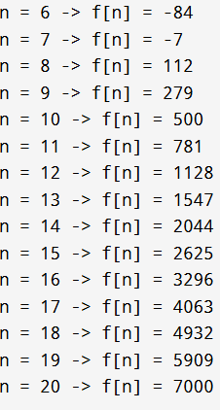
}
#include <stdio.h>
int main()
{
int n, f;
for (n = -20; n <= 20; n++)
{
if (n <= -10)
f = n * n - 5 * n;
else if (n > -10 && n < -2) // FIXED condition
f = n + 19;
else
f = n * n * n - 50 * n;

printf("For n = %d, f = %d\n", n, f);
}
return 0;
}

Conclusion: The condition -10 < n < -2 was the main logical error. In C, this doesn't work as a mathematical range. Using && operator correctly implements the range check, producing accurate results matching Task 2.
Critical Analysis
This lab provided hands-on experience with the complete C programming workflow:
- Task 1 demonstrated that syntax errors are easily detectable by the compiler but require attention to detail (case sensitivity, semicolons, quotes).
- Task 2 highlighted the importance of having expected outputs before testing programs.
- Task 3 showed that logical errors are more challenging to find than syntax errors, as programs run but produce incorrect results. Debuggers are essential tools for tracing such errors.
The combination of manual calculation, debugging tools, and systematic error identification forms a robust approach to developing correct and reliable C programs.

